**PL/SQL Programming**

**Exercise 1: Control Structures**

**Code:**

BEGIN

EXECUTE IMMEDIATE 'DROP TABLE customers_loans';

EXCEPTION

WHEN OTHERS THEN NULL;

END;

**/**

CREATE TABLE customers_loans (

customer_id NUMBER PRIMARY KEY,

name VARCHAR2(50),

age NUMBER,

balance NUMBER,

isvip VARCHAR2(5),

interest_rate NUMBER,

due_date DATE

);

INSERT INTO customers_loans VALUES (1, 'Tommy', 68, 7000, 'FALSE', 6.0, SYSDATE + 50);

INSERT INTO customers_loans VALUES (2, 'Rohan', 45, 12000, 'FALSE', 5.5, SYSDATE + 60);

INSERT INTO customers_loans VALUES (3, 'Sunny', 30, 9000, 'FALSE', 6.8, SYSDATE + 10);

INSERT INTO customers_loans VALUES (4, 'Vicky', 70, 13000, 'FALSE', 5.0, SYSDATE + 40);

INSERT INTO customers_loans VALUES (5, 'Faran', 40, 11000, 'FALSE', 6.2, SYSDATE + 5);

INSERT INTO customers_loans VALUES (6, 'Neha', 35, 8000, 'FALSE', 6.5, SYSDATE + 90);

COMMIT;

select * from customers_loans;

--Table is Created

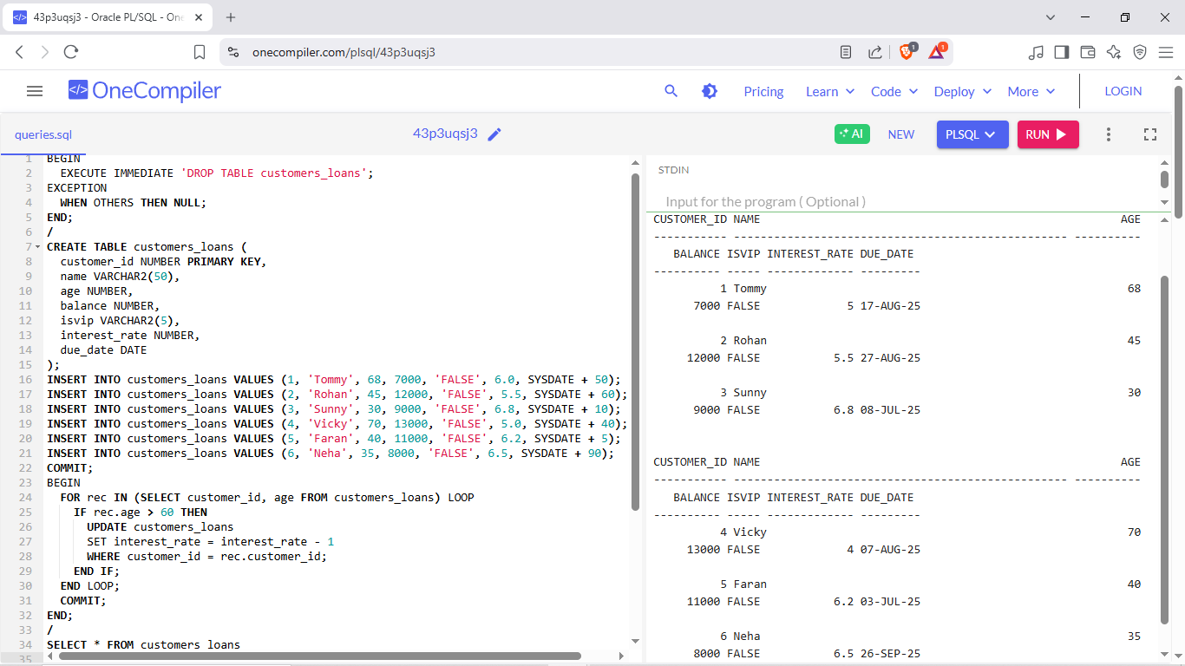

**Scenario 1:** The bank wants to apply a discount to loan interest rates for customers above 60

years old.

Write a PL/SQL block that loops through all customers, checks their age, and if

**Code:**

BEGIN

EXECUTE IMMEDIATE 'DROP TABLE customers_loans';

EXCEPTION

WHEN OTHERS THEN NULL;

END;

**/**

CREATE TABLE customers_loans (

customer_id NUMBER PRIMARY KEY,

name VARCHAR2(50),

age NUMBER,

balance NUMBER,

isvip VARCHAR2(5),

interest_rate NUMBER,

due_date DATE

);

INSERT INTO customers_loans VALUES (1, 'Tommy', 68, 7000, 'FALSE', 6.0, SYSDATE + 50);

INSERT INTO customers_loans VALUES (2, 'Rohan', 45, 12000, 'FALSE', 5.5, SYSDATE + 60);

INSERT INTO customers_loans VALUES (3, 'Sunny', 30, 9000, 'FALSE', 6.8, SYSDATE + 10);

INSERT INTO customers_loans VALUES (4, 'Vicky', 70, 13000, 'FALSE', 5.0, SYSDATE + 40);

INSERT INTO customers_loans VALUES (5, 'Faran', 40, 11000, 'FALSE', 6.2, SYSDATE + 5);

INSERT INTO customers_loans VALUES (6, 'Neha', 35, 8000, 'FALSE', 6.5, SYSDATE + 90);

COMMIT;

BEGIN

FOR rec IN (SELECT customer_id, age FROM customers_loans) LOOP

IF rec.age > 60 THEN

UPDATE customers_loans

SET interest_rate = interest_rate - 1

WHERE customer_id = rec.customer_id;

END IF;

END LOOP;

COMMIT;

END;

**/**

SELECT * FROM customers_loans

WHERE age > 60 AND interest_rate < 6;

**Output:**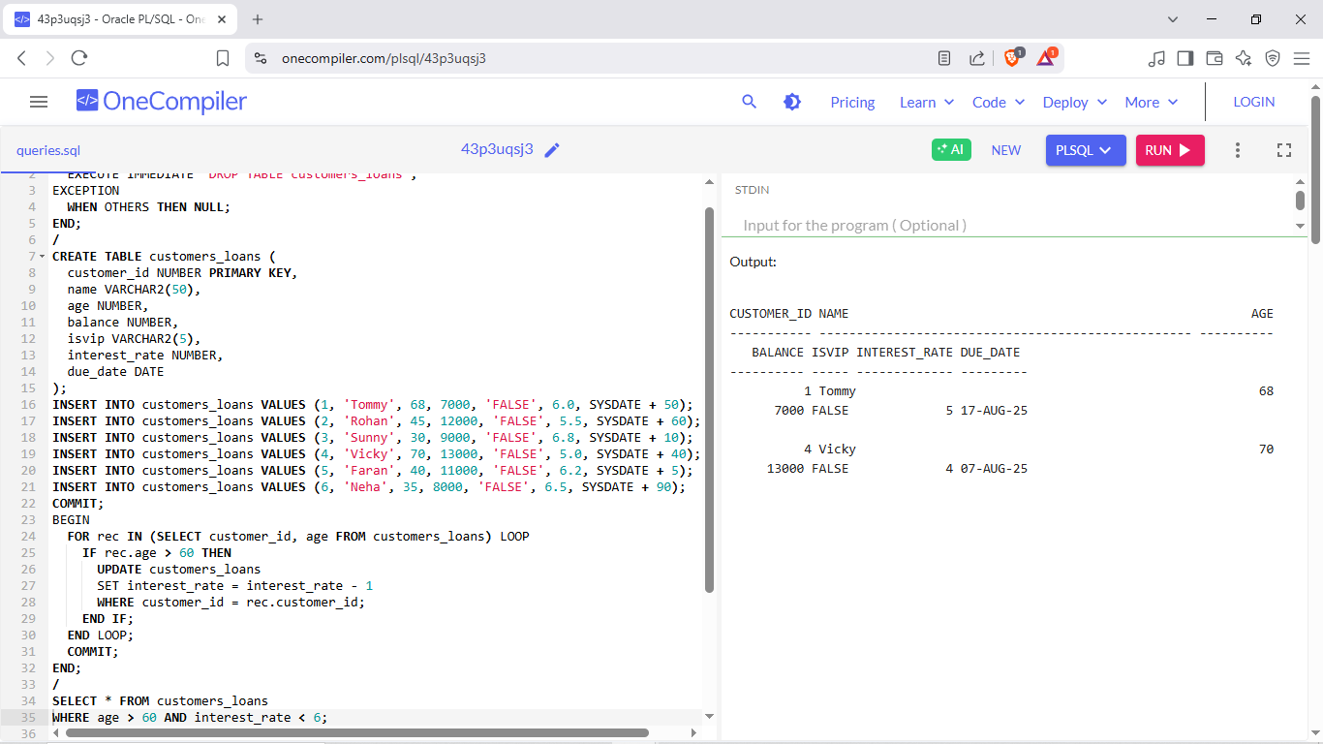

**Scenario 2:** A customer can be promoted to VIP status based on their balance.

Write a PL/SQL block that iterates through all customers and sets a flag IsVIP

to TRUE for those with a balance over $10,000.

**Code:**

BEGIN

EXECUTE IMMEDIATE 'DROP TABLE customers_loans';

EXCEPTION

WHEN OTHERS THEN NULL;

END;

/

CREATE TABLE customers_loans (

customer_id NUMBER PRIMARY KEY,

name VARCHAR2(50),

age NUMBER,

balance NUMBER,

isvip VARCHAR2(5),

interest_rate NUMBER,

due_date DATE

);

INSERT INTO customers_loans VALUES (1, 'Tommy', 68, 7000, 'FALSE', 6.0, SYSDATE + 50);

INSERT INTO customers_loans VALUES (2, 'Rohan', 45, 12000, 'FALSE', 5.5, SYSDATE + 60);

INSERT INTO customers_loans VALUES (3, 'Sunny', 30, 9000, 'FALSE', 6.8, SYSDATE + 10);

INSERT INTO customers_loans VALUES (4, 'Vicky', 70, 13000, 'FALSE', 5.0, SYSDATE + 40);

INSERT INTO customers_loans VALUES (5, 'Faran', 40, 11000, 'FALSE', 6.2, SYSDATE + 5);

INSERT INTO customers_loans VALUES (6, 'Neha', 35, 8000, 'FALSE', 6.5, SYSDATE + 90);

COMMIT;

BEGIN

FOR rec IN (SELECT customer_id, balance FROM customers_loans) LOOP

IF rec.balance > 10000 THEN

UPDATE customers_loans SET isvip = 'TRUE'

WHERE customer_id = rec.customer_id;

END IF;

END LOOP;

COMMIT;

END;

**/**

SELECT * FROM customers_loans

WHERE isvip ='TRUE';

**Output:**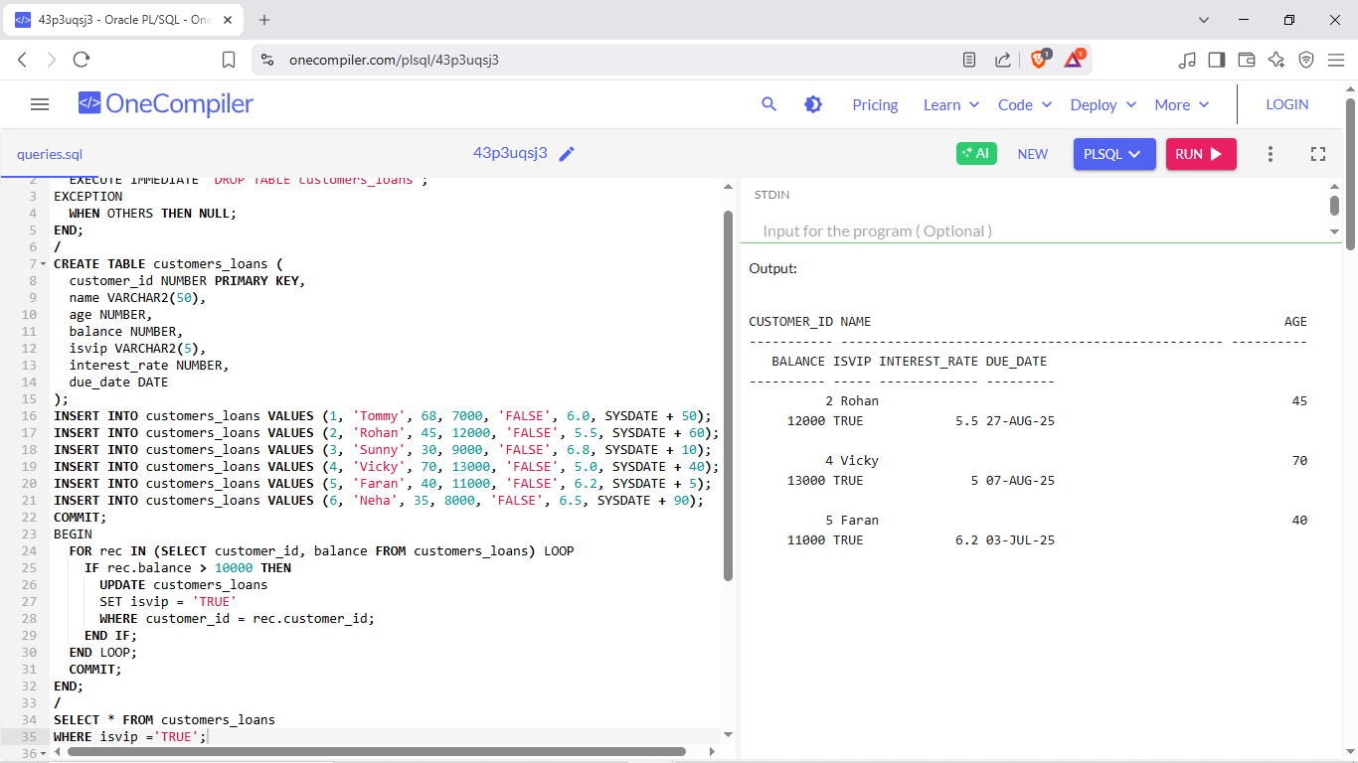

**Scenario 3:** The bank wants to send reminders to customers whose loans are due within the

next 30 days. Write a PL/SQL block that fetches all loans due in the next 30 days and prints a

reminder message for each customer.

**Code:**

BEGIN

EXECUTE IMMEDIATE 'DROP TABLE customers_loans';

EXCEPTION

WHEN OTHERS THEN NULL;

END;

/

CREATE TABLE customers_loans (

customer_id NUMBER PRIMARY KEY,

name VARCHAR2(50),

age NUMBER,

balance NUMBER,

isvip VARCHAR2(5),

interest_rate NUMBER,

due_date DATE

);

INSERT INTO customers_loans VALUES (1, 'Tommy', 68, 7000, 'FALSE', 6.0, SYSDATE + 50);

INSERT INTO customers_loans VALUES (2, 'Rohan', 45, 12000, 'FALSE', 5.5, SYSDATE + 60);

INSERT INTO customers_loans VALUES (3, 'Sunny', 30, 9000, 'FALSE', 6.8, SYSDATE + 10);

INSERT INTO customers_loans VALUES (4, 'Vicky', 70, 13000, 'FALSE', 5.0, SYSDATE + 40);

INSERT INTO customers_loans VALUES (5, 'Faran', 40, 11000, 'FALSE', 6.2, SYSDATE + 5);

INSERT INTO customers_loans VALUES (6, 'Neha', 35, 8000, 'FALSE', 6.5, SYSDATE + 90);

COMMIT;

BEGIN

FOR rec IN (SELECT name, due_date

FROM customers_loans

WHERE due_date BETWEEN SYSDATE AND SYSDATE + 30

) LOOP

DBMS_OUTPUT.PUT_LINE('Reminder: Dear ' || rec.name || ', your loan is due on ' || TO_CHAR(rec.due_date, 'DD-MON-YYYY'));

END LOOP;

END;

**/**

**Output:**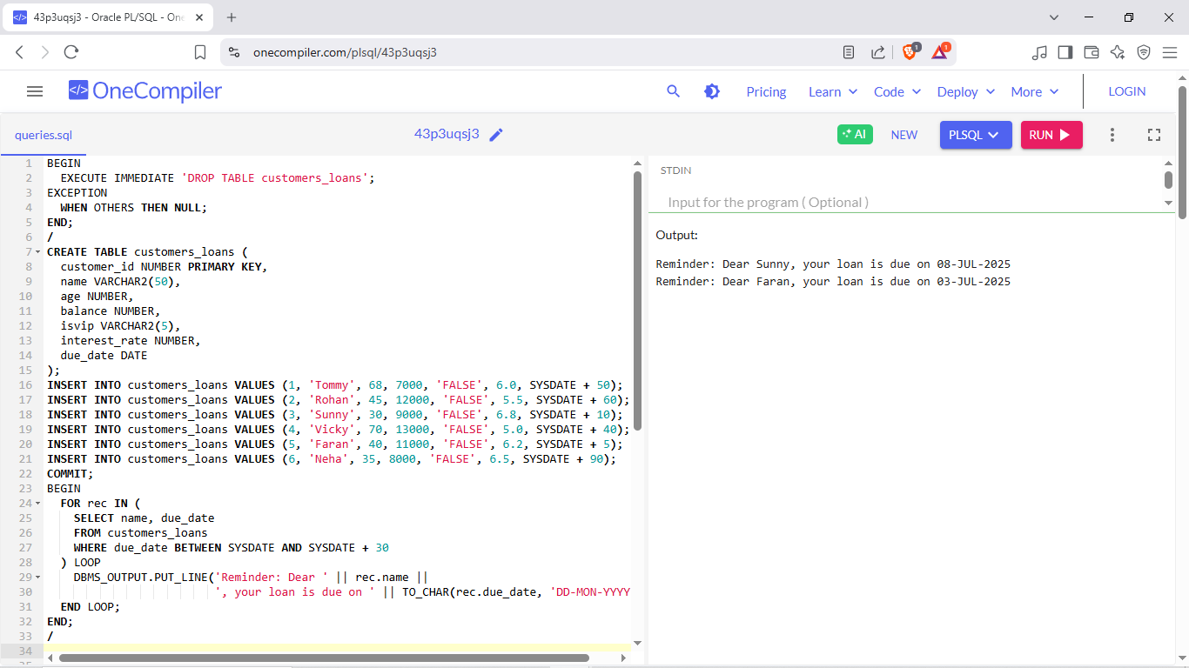

**Exercise 3: Stored Procedures**

**Code:**

BEGIN

EXECUTE IMMEDIATE 'DROP TABLE accounts';

EXCEPTION

WHEN OTHERS THEN NULL;

END;

**/**

CREATE TABLE accounts (

acc_id NUMBER PRIMARY KEY,

name VARCHAR2(50),

acc_type VARCHAR2(20),

department VARCHAR2(30),

balance NUMBER

);

INSERT INTO accounts VALUES (1, 'Amar', 'savings', NULL, 10000);

INSERT INTO accounts VALUES (2, 'Bala', 'savings', NULL, 20000);

INSERT INTO accounts VALUES (3, 'Seetha', 'savings', NULL, 5000);

INSERT INTO accounts VALUES (4, 'Ravi', 'employee', 'IT', 40000);

INSERT INTO accounts VALUES (5, 'Neha', 'employee', 'HR', 35000);

INSERT INTO accounts VALUES (6, 'Karan', 'employee', 'IT', 45000);

COMMIT;

Table is Created

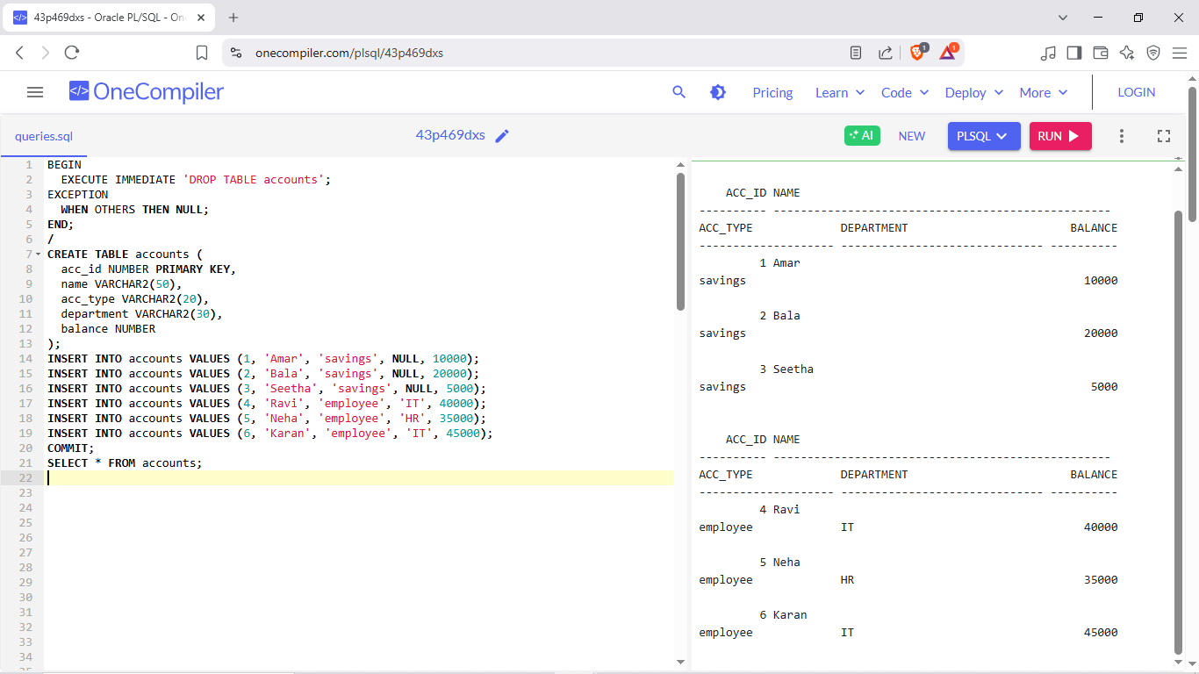

**Scenario 1:** The bank needs to process monthly interest for all savings accounts.

Write a stored procedure ProcessMonthlyInterest that calculates and updates

the balance of all savings accounts by applying an interest rate of 1% to the current

Balance.

**Code:**

BEGIN

EXECUTE IMMEDIATE 'DROP TABLE accounts';

EXCEPTION

WHEN OTHERS THEN NULL;

END;

**/**

CREATE TABLE accounts (

acc_id NUMBER PRIMARY KEY,

name VARCHAR2(50),

acc_type VARCHAR2(20),

department VARCHAR2(30),

balance NUMBER

);

INSERT INTO accounts VALUES (1, 'Amar', 'savings', NULL, 10000);

INSERT INTO accounts VALUES (2, 'Bala', 'savings', NULL, 20000);

INSERT INTO accounts VALUES (3, 'Seetha', 'savings', NULL, 5000);

INSERT INTO accounts VALUES (4, 'Ravi', 'employee', 'IT', 40000);

INSERT INTO accounts VALUES (5, 'Neha', 'employee', 'HR', 35000);

INSERT INTO accounts VALUES (6, 'Karan', 'employee', 'IT', 45000);

COMMIT;

CREATE OR REPLACE PROCEDURE ProcessMonthlyInterest AS

BEGIN

UPDATE savings_accounts

SET balance = balance + (balance * 0.01);

END;

**/**

BEGIN

ProcessMonthlyInterest;

END;

**/**

select * from savings_accounts;

**Output:**

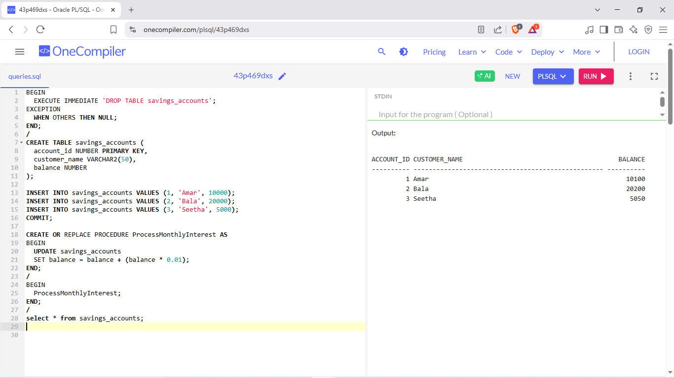

**Scenario 2:** The bank wants to implement a bonus scheme for employees based on their

performance.

Write a stored procedure UpdateEmployeeBonus that updates the salary of

employees in a given department by adding a bonus percentage passed as a parameter**.**

**Code:**

BEGIN

EXECUTE IMMEDIATE 'DROP TABLE accounts';

EXCEPTION

WHEN OTHERS THEN NULL;

END;

**/**

CREATE TABLE accounts (

acc_id NUMBER PRIMARY KEY,

name VARCHAR2(50),

acc_type VARCHAR2(20),

department VARCHAR2(30),

balance NUMBER

);

INSERT INTO accounts VALUES (1, 'Amar', 'savings', NULL, 10000);

INSERT INTO accounts VALUES (2, 'Bala', 'savings', NULL, 20000);

INSERT INTO accounts VALUES (3, 'Seetha', 'savings', NULL, 5000);

INSERT INTO accounts VALUES (4, 'Ravi', 'employee', 'IT', 40000);

INSERT INTO accounts VALUES (5, 'Neha', 'employee', 'HR', 35000);

INSERT INTO accounts VALUES (6, 'Karan', 'employee', 'IT', 45000);

COMMIT;

CREATE OR REPLACE PROCEDURE UpdateEmployeeBonus (

dept_name IN VARCHAR2,

bonus_percent IN NUMBER

) AS

BEGIN

UPDATE accounts

SET balance = balance + (balance * bonus_percent / 100)

WHERE acc_type = 'employee' and department=dept_name;

DBMS_OUTPUT.PUT_LINE('Bonus applied to ' || dept_name || ' department.');

END;

**/**

BEGIN

UpdateEmployeeBonus('IT', 10);

END;

**/**

SELECT * FROM accounts;

**Output:**

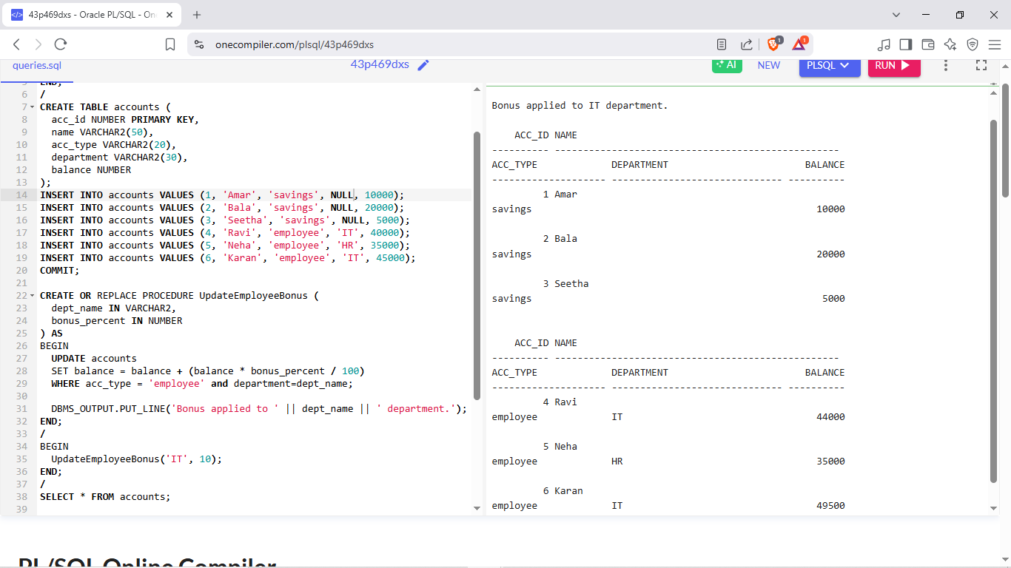

**Scenario 3:** Customers should be able to transfer funds between their accounts.

Write a stored procedure TransferFunds that transfers a specified amount

from one account to another, checking that the source account has sufficient balance

before making the transfer.

**Code:**

BEGIN

EXECUTE IMMEDIATE 'DROP TABLE accounts';

EXCEPTION

WHEN OTHERS THEN NULL;

END;

**/**

CREATE TABLE accounts (

acc_id NUMBER PRIMARY KEY,

name VARCHAR2(50),

acc_type VARCHAR2(20),

department VARCHAR2(30),

balance NUMBER

);

INSERT INTO accounts VALUES (1, 'Amar', 'savings', NULL, 10000);

INSERT INTO accounts VALUES (2, 'Bala', 'savings', NULL, 20000);

INSERT INTO accounts VALUES (3, 'Seetha', 'savings', NULL, 5000);

INSERT INTO accounts VALUES (4, 'Ravi', 'employee', 'IT', 40000);

INSERT INTO accounts VALUES (5, 'Neha', 'employee', 'HR', 35000);

INSERT INTO accounts VALUES (6, 'Karan', 'employee', 'IT', 45000);

COMMIT;

CREATE OR REPLACE PROCEDURE TransferFunds (

from_id IN NUMBER,

to_id IN NUMBER,

amount IN NUMBER

) AS

from_balance NUMBER;

BEGIN

SELECT balance INTO from_balance FROM accounts WHERE acc_id = from_id;

IF from_balance < amount THEN

DBMS_OUTPUT.PUT_LINE('Insufficient balance in source account.'|| from_id);

ELSE

UPDATE accounts SET balance = balance - amount

WHERE acc_id = from_id;

UPDATE accounts SET balance = balance + amount

WHERE acc_id = to_id;

DBMS_OUTPUT.PUT_LINE('Transfer successful: ' || amount || ' transferred.');

END IF;

END;

**/**

BEGIN

TransferFunds(6, 5, 7000);

END;

**/**

SELECT * FROM accounts;

**Output:**

